Sri Lanka Institute of Information

Technology



Lab Submission

Lab sheet 10

**<IT24100966>**

**<Kaluarachchige P.E.K>**

**IT2120- Probability and Statistics**

B.Sc. (Hons) in Information Technology

Exercise

1. H0: Customers choose all four snack types (A, B, C, D) equally.

H1: Customers do not choose all four snack types equally.

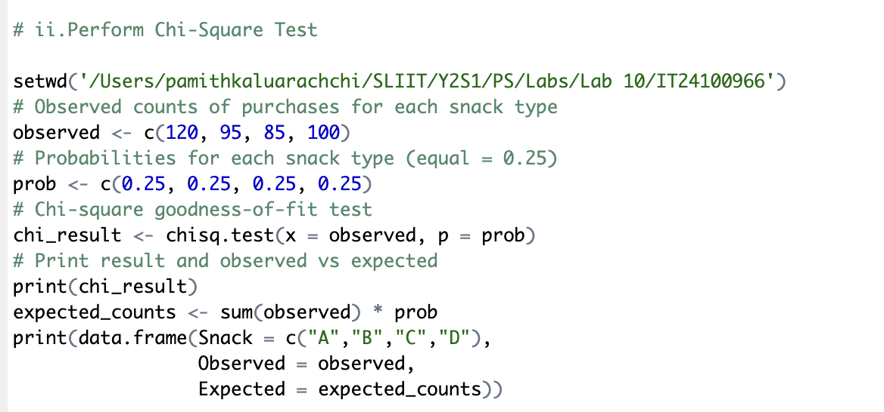

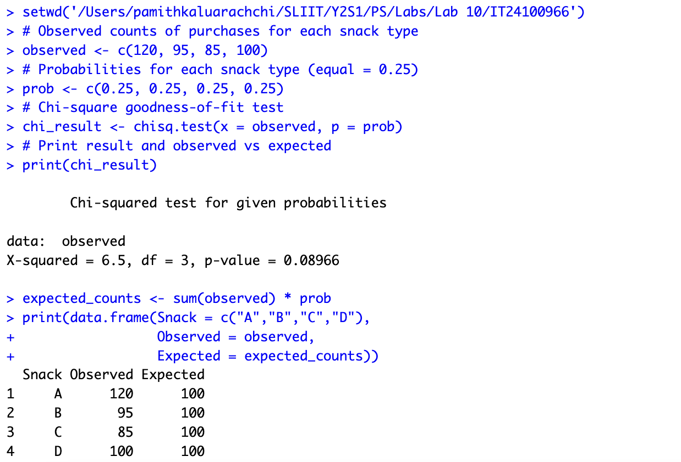

1. Significance level: α = 0.05

p-value = 0.089

Since p-value (0.089) > 0.05,

fail to reject H₀